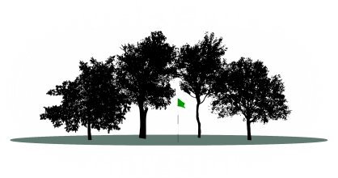
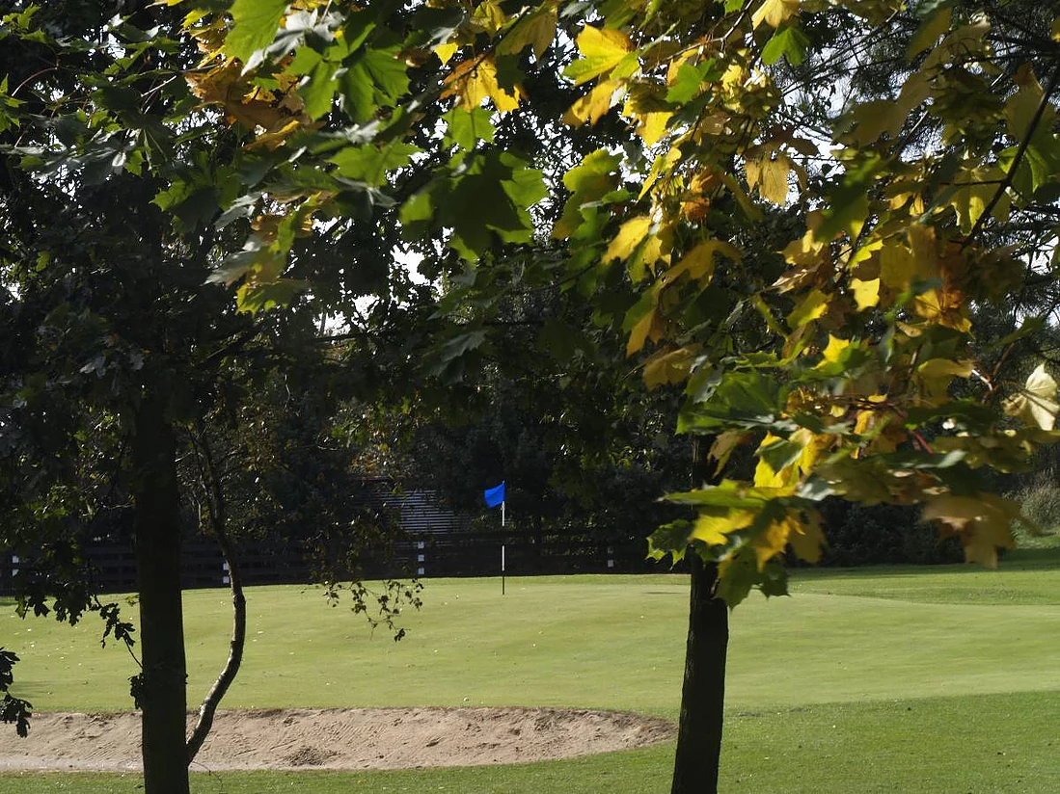
Brierley Forest Golf Club
160 Main Street
Huthwaite
NG17 2LG
Tel: 01623 550761

Members
A

Minutes
Tuesday 29th September 2026 – 19:00

Apologies
Ryan Bailey | President | P | Danny Armes | Captain | A
Nat Matchett | Secretary | P | Derek Gillings | Vice-Captain | A
Paul Burford | Treasurer | P | Libbie Harvey | Senior Captain Correspondance | A
Dan Binch | H/Cap Secretary | P
Matt Harvey | Gen Comm | A | Henry Binch | Gen Comm | P
Dan Nelson | Gen Comm | A | Roy Cantrill | Gen Comm | P
Dale Marsh | Gen Comm | P | Paul Griffin | Gen Comm | A
John Webster | Gen Comm | P | Derek Gillings | Taskers A | A
 |  |  | Shaun Ballantine | Taskers B | P
 |  |  | Grant Matchett | Scratch Captain | P
 |  |  | Jay Coupe | Alliance Captain | A
Grant Matchett | Management | P
Paul Bough | Management | A

Previous Minutes
Were read & accepted as a true record.
Proposed: DM Seconded: PB

Agenda
- Nothing sent in or for AOB

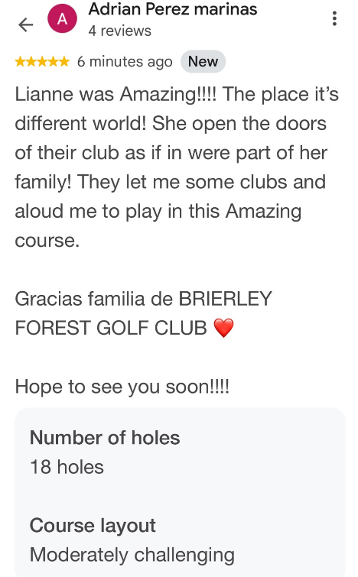
Matters Arising (Not on Agenda)
- N/A

Correspondence
- Taskers team entries for 2027 received and passed onto DG and SB
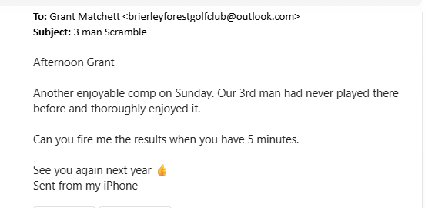
- Some great feedback about the course from Spanish visitors and open comp visitors
- The infamous Halloween party is back Sat 31st October get your tickets

Management Report
Course
Just been able to try and keep on top of cutting.
New fairway mower has arrived
Hoping new hand mowers arrive next week
Acquired a new digger for a short period of time for the 6th ditch so hoping this will be finished by this Thurs/Fri other than man hole covers

Clubhouse
Staff wondered for comps if CDH numbers could be requested prior as does take time c chasing them up. DB mentioned maybe a BRS admin issue as is greyed out and maybe contact Steph as BRS – NM to action.
Yellow visitor bag tags now in operation

Captain’s Report
Hi all

I would like to thank everyone who continues to support the weekly football cards, as well as the bar staff for their ongoing assistance in managing them. Their support is greatly appreciated.

Members are reminded that the sheet for claiming winnings from the T-shirt Football Card is still available. However, no names have been added yet, so no payments have been issued.

Once names are recorded on the sheet, the relevant winnings will be placed in a sealed envelope and left behind the bar, clearly marked with the member's name and the amount owed. The sheet is used to keep an accurate record of payments issued and collected, helping to ensure there is a clear trail and to avoid any misunderstandings.

Kind regards
D.Armes

Treasurer Report
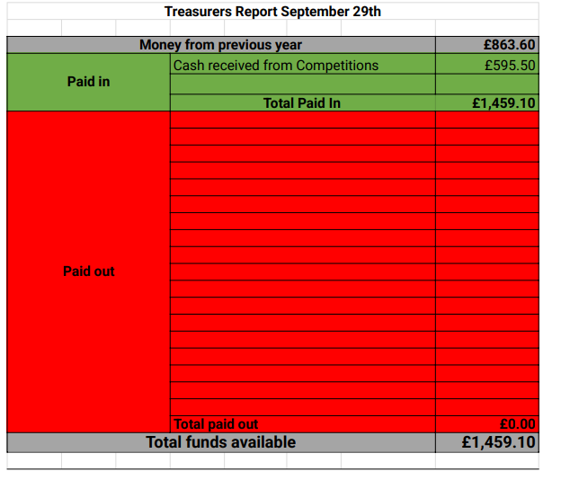
Handicap/Competition Secretary Report
Good Evening Everyone
- A new Golf Genius update should make viewing and entering Match play knockout results available on the app
- Summer League matches need completing ASAP
- Presidents Trophy entry list will be posted as soon as quarter final round of the Summer League is complete
- I am hoping to continue the Mid-Week competition through October as long as the weather and course conditions will allow
- This will mean a winter League that will run from Nov 1st through to February 28th
- I have swopped the Halloween Foursomes comp on the Sat 24th Oct to the Sat 31st Oct having noticed this in the fixtures booklet that Halloween actually fell on the 31st so a simple swop to these comps has been done
- I would be interested in anyone’s thoughts as to how best sort the Order Of Merit. As the OOM comes to a conclusion we currently have results spread over the 2 systems used this season. While the same format was applied for both systems 1 no longer have access to the details kept on Handicap Master. I did save the last oom table before we switched but this doesn’t show the full details.
After further discussion at the committee the OOM results will take a little time to process due to the software changes - so please bear with us.

Thanks
Dan.

Scratch Team Captains Report
Nothing to report

Alliance Team Report NAPGA (Alliance) napga.co.uk
PB Brierley reported BFGC are sitting 2nd this year after 4 events in Order of merit and Carl Hough leading on top of the single Order of merit. Also, last year’s penultimate event Harry Brown from last year’s top 8 teams Brierley took the win! A huge well done from the committee to the team!

Senior Taskers Team A Report
Nothing new to report

We go again next year.

Kind Regards,
Derek Gillings

Senior Taskers Team B Report
Nothing to report

Senior Captains Report
A big thank you to all the players who played in the seniors friendly against Alfreton. Also thank you to Nat and Grant for the use of the course. The players from both sides complimented the good standard of the course . So a well done to Lee and Paul too .

Also thank you to Nat and Tash for the food. Alfreton said they are looking forward to next year for the home and away fixture to which our senior members said the same. We also won 4.5 to 1.5 to Brierley today so a great result too. Thanks to al involved,

Senior Captain – Ian Petrovics

Juniors Captain Report
No Report - Vacant

Ladies Captain Report
No Report - Vacant

AOB
- Ryan Bailey – wanted to reiterate how well the course is looking and playing compared to a few weeks ago – well done the lads.

Finished 7.36pm

Next Meeting – Committee: Tues 3rd November 2026, 7pm

